Programming Assign. Unit 6

The cyclomatic complexity is calculated using the quick sort algorithm as an example.

**1. Draw the flowchart of the above algorithm.**

A flowchart regarding the quick sort algorithm is described below. I performed the creation in mermaid format and output as an image.

QUICKSORT(A, p, r)

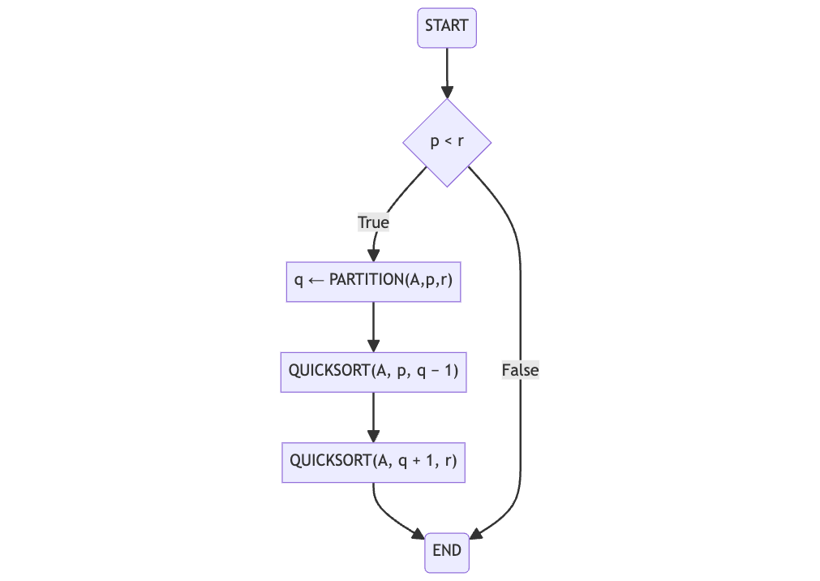

PARTITION(A, p, r)

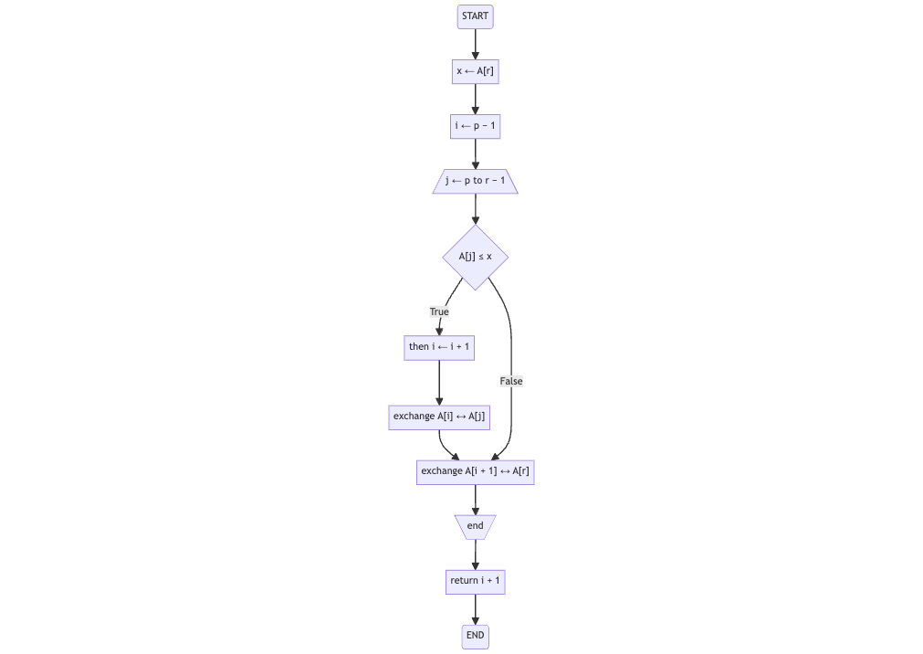

**2. Draw the corresponding graph and label the nodes as n1, n2, … and edges as e1, e2, …**

Describe how the graph corresponds to the flowchart. The graphs are made in mermaid format and output as images.

QUICKSORT(A, p, r)

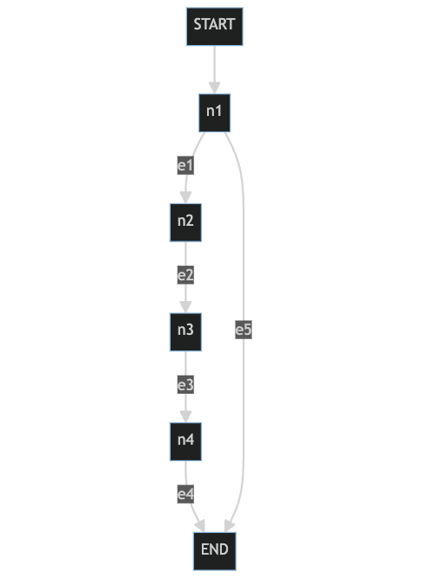

PARTITION(A, p, r)

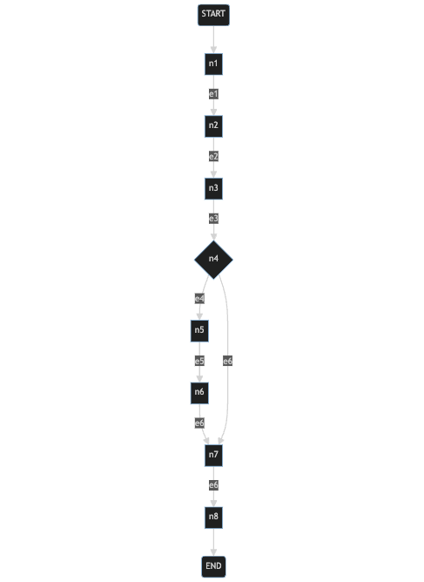

**3. Calculate the cyclomatic complexity of the above algorithm**

In order to calculate the cyclomatic complexity, it is necessary to be aware that PARTITION(A, p, r) is one of the QUICKSORT processes. The results are described below.

Number of nodes (N): 4+8-1=11

Number of edges (E):13

Number of connected components (P):1

V=E-N+2P

=13-11+2 $×$ 1

=4